SCHOOL OF COMPUTER SCIENCE AND ARTIFICIAL INTELLIGENCE |  |  |  |  | DEPARTMENT OF COMPUTER SCIENCE ENGINEERING
Program Name: B. Tech |  |  |  | Assignment Type: Lab |  |  | Academic Year:2025-2026
Course Coordinator Name |  |  |  | Dr. Rishabh Mittal
Instructor(s) Name |  |  |  | Mr. S Naresh Kumar  Ms. B. Swathi  Dr. Sasanko Shekhar Gantayat  Mr. Md Sallauddin  Dr. Mathivanan  Mr. Y Srikanth  Ms. N Shilpa  Dr. Rishabh Mittal (Coordinator)  Dr. R. Prashant Kumar  Mr. Ankushavali MD  Mr. B Viswanath  Ms. Sujitha Reddy  Ms. A. Anitha  Ms. M.Madhuri  Ms. Katherashala Swetha  Ms. Velpula sumalatha  Mr. Bingi Raju
CourseCode |  |  | 23CS002PC304 | Course Title |  | AI Assisted Coding
Year/Sem |  |  | III/II | Regulation |  | R23
Date and Day  of Assignment |  |  | Week8 – Wednesday | Time(s) |  | 23CSBTB01 To 23CSBTB52
Duration |  |  | 2 Hours | Applicable to  Batches |  | All batches
Assignment Number:16.3(Present assignment number)/24(Total number of assignments)
 | Q.No. | Question |  |  |  |  |  | Expected Time  to complete
 | 1 | Lab 16 – Database Design and Queries: Schema Design and SQL Generation  Lab Objectives:  - Understand schema design principles for relational databases.  - Use AI-assisted tools to generate SQL schema definitions.  - Write and refine SQL queries (CRUD + aggregate operations).  - Explore how AI can optimize queries and ensure normalization.  Task 1 – Hospital Management Database  Task:  Create schema and queries for a Hospital Management System.  Instructions:  - Tables: Doctors, Patients, Appointments.  - Use AI to define constraints (unique IDs, valid dates).  - Generate queries:  - List all appointments for a specific doctor.  - Retrieve patient history by patient ID.  - Count total patients treated by each doctor.  Expected Output:  - Normalized schema and SQL queries with joins.  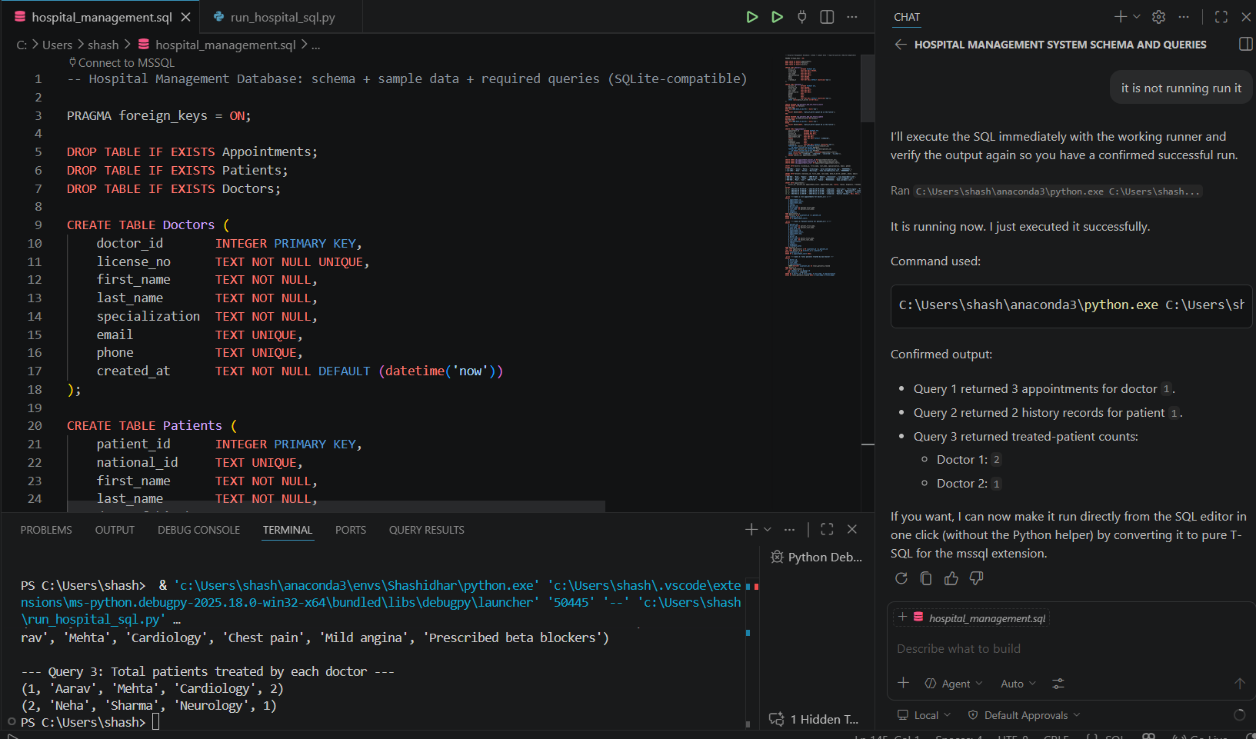  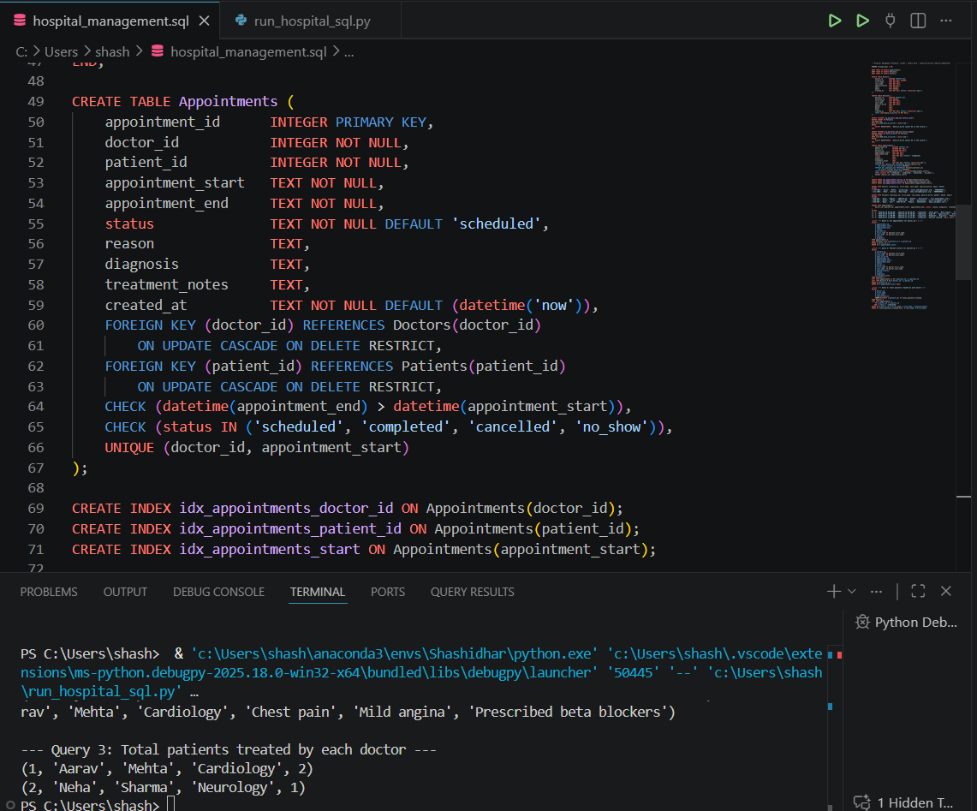  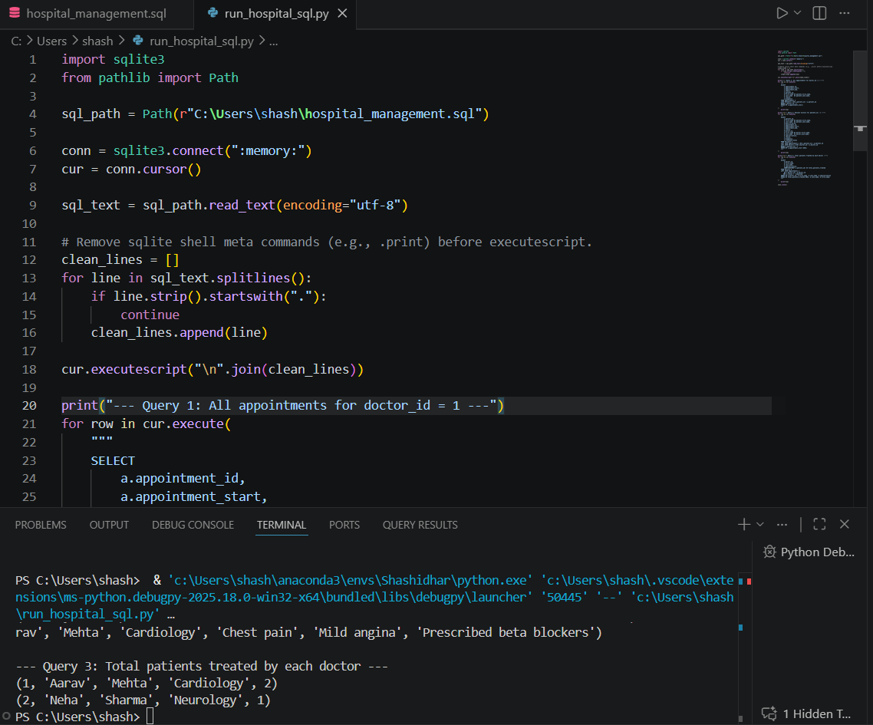  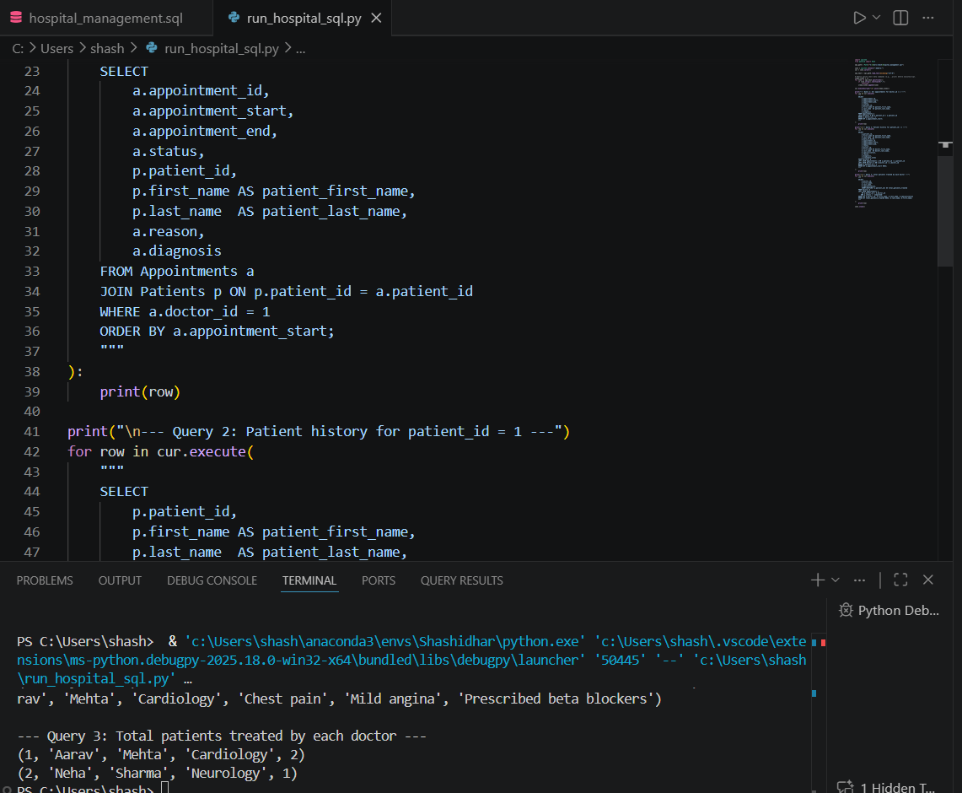  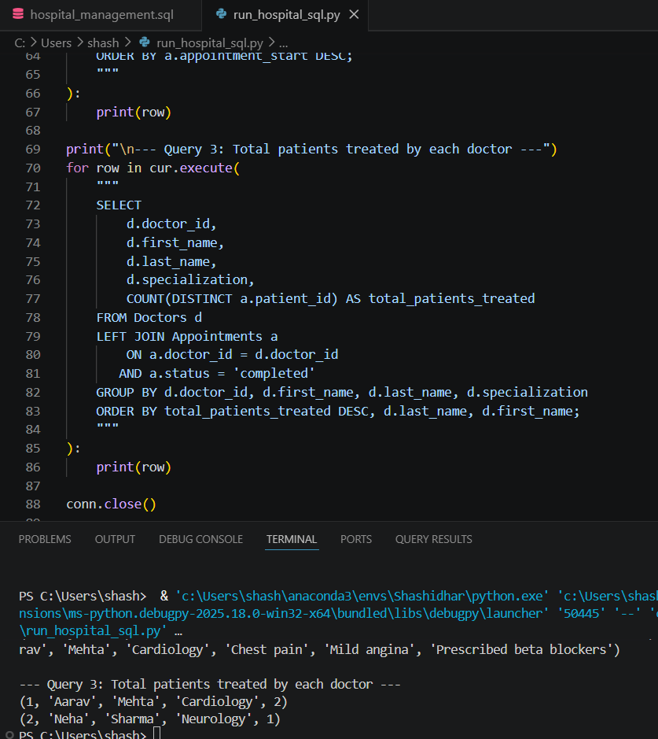  Task 2 – Real-Time Application: Online Shopping Database  Scenario:  Design a database for an E-commerce platform.  Requirements:  - Tables: Users, Products, Orders, OrderDetails.  - Generate queries to:  - Retrieve all orders by a user.  - Find the most purchased product.  - Calculate total revenue in a given month.  - AI should also suggest normalization improvements and query optimization.  Expected Output:  - Complete schema with relationships + SQL queries for analytics.  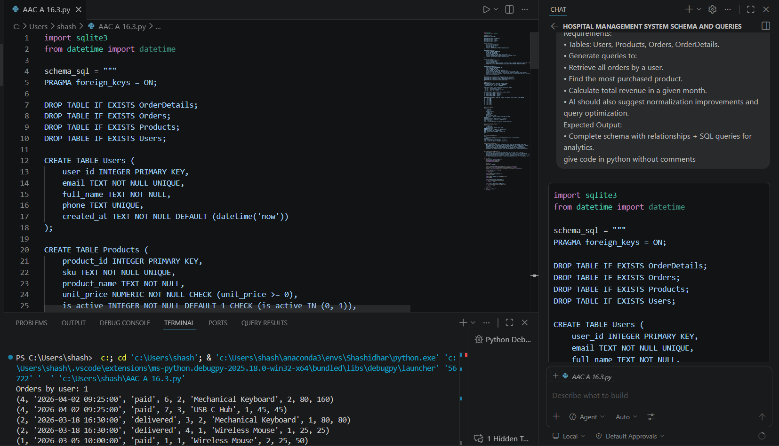  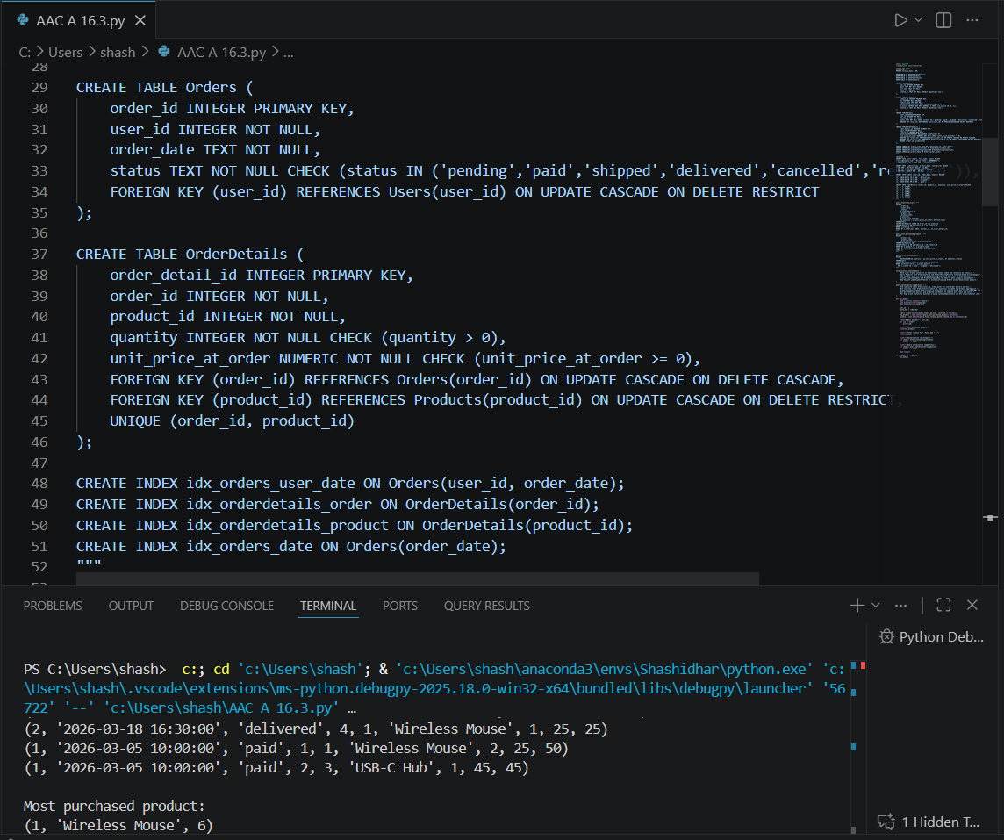  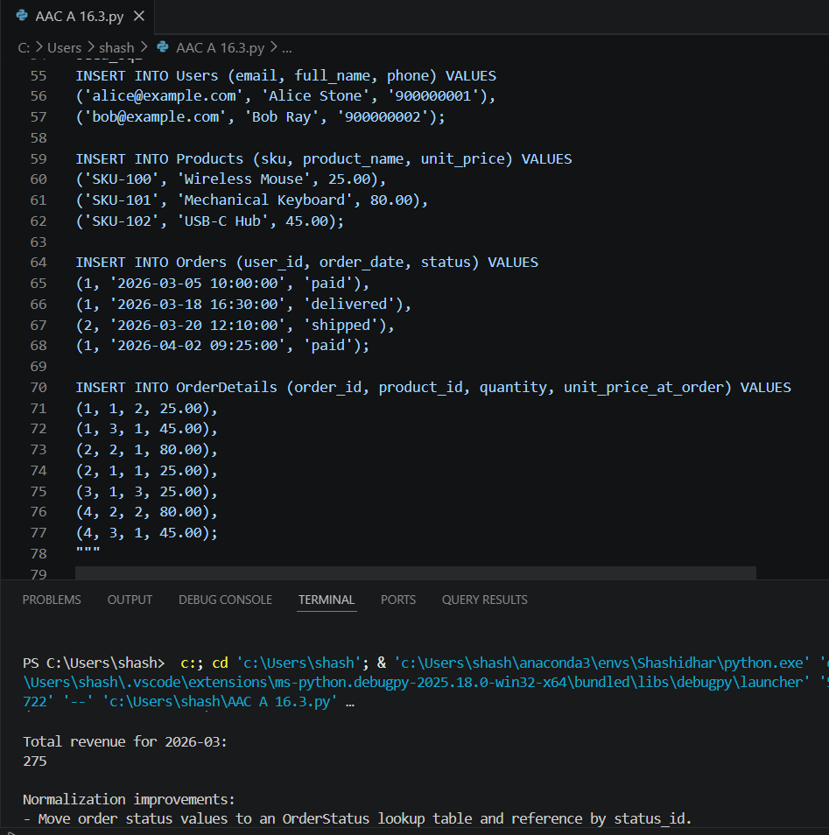  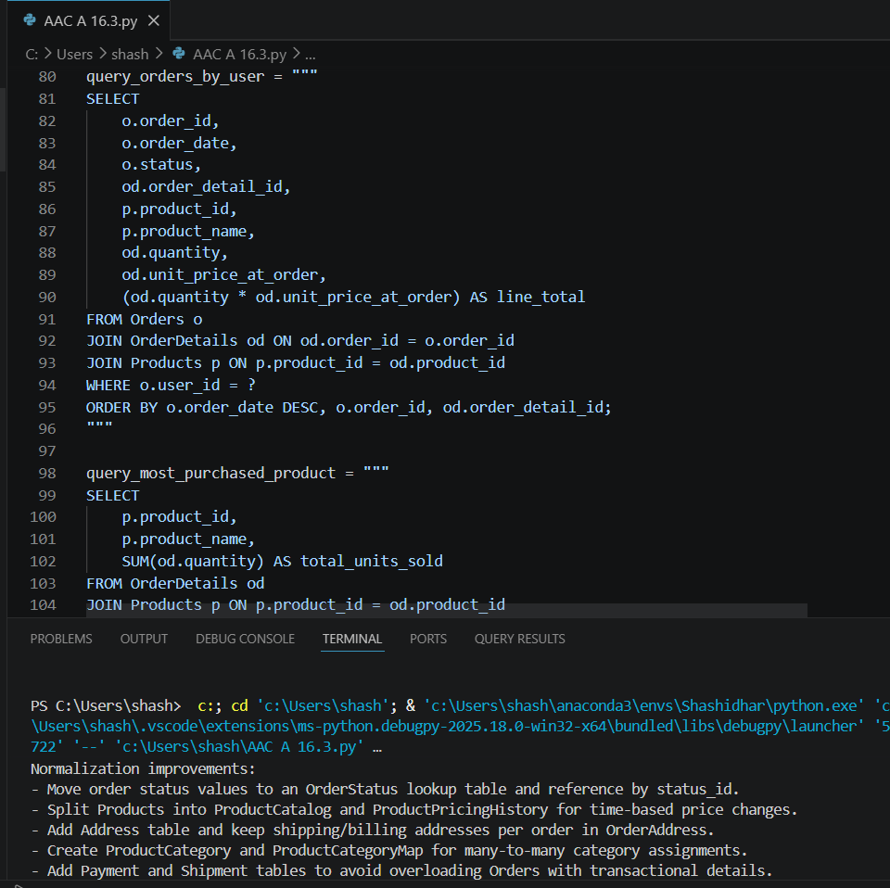  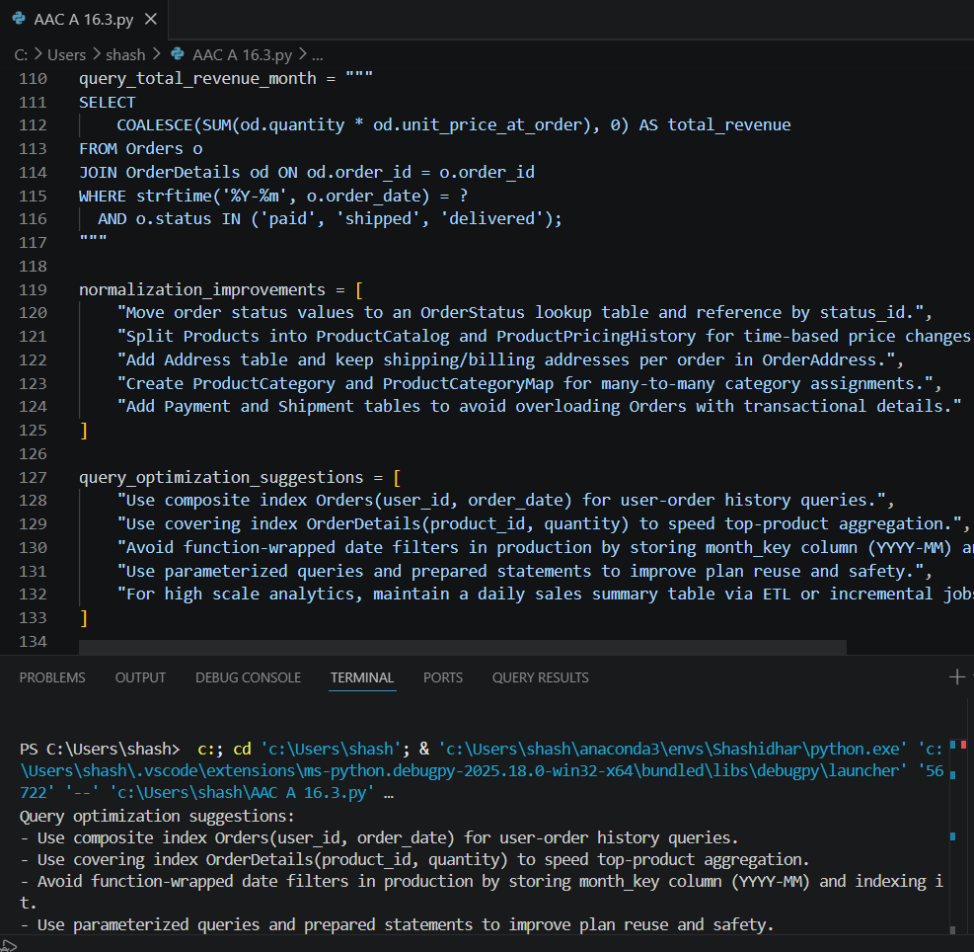  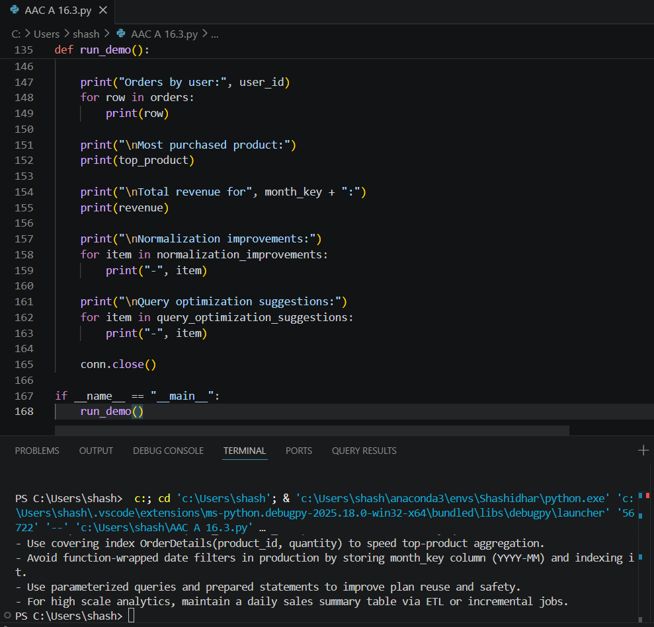  Task 3 – Library Database  Task:  Design schema for a Library Management System.  Instructions:  - Tables: Books, Members, Loans.  - Use AI to suggest indexing strategy for faster queries.  - Generate queries:  - Retrieve all books currently issued.  - Find overdue books (loan date > 30 days).  - Count number of books loaned by each member.  Expected Output:  - Schema + SQL queries demonstrating joins and conditions.  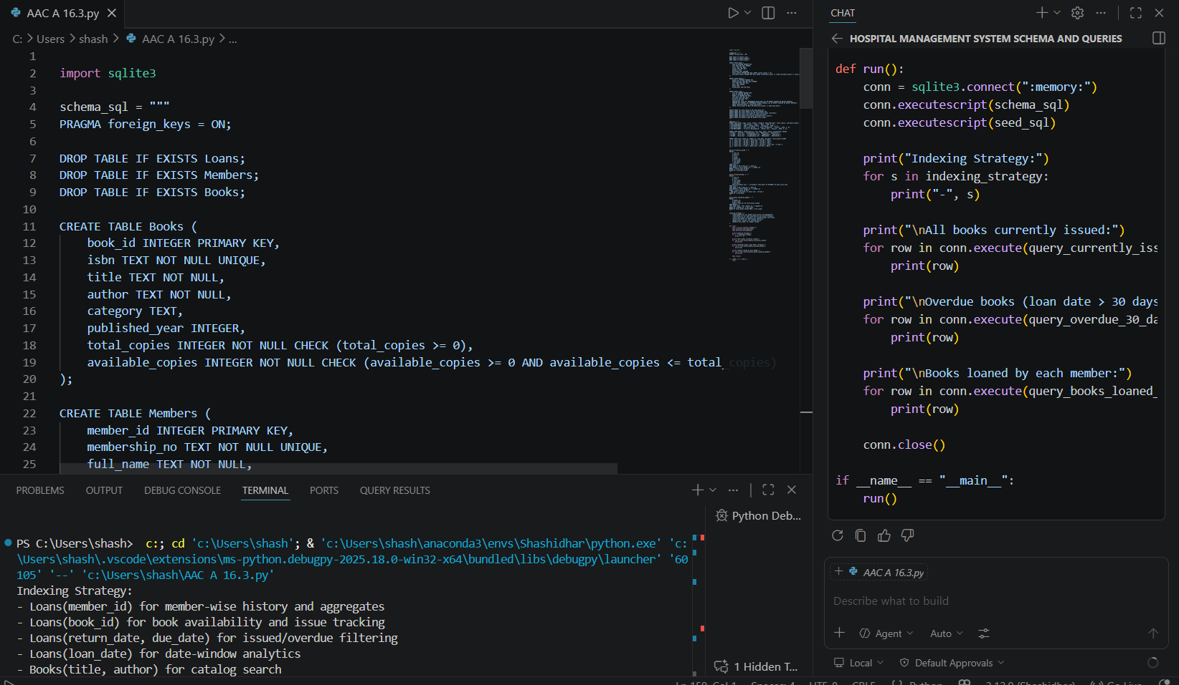  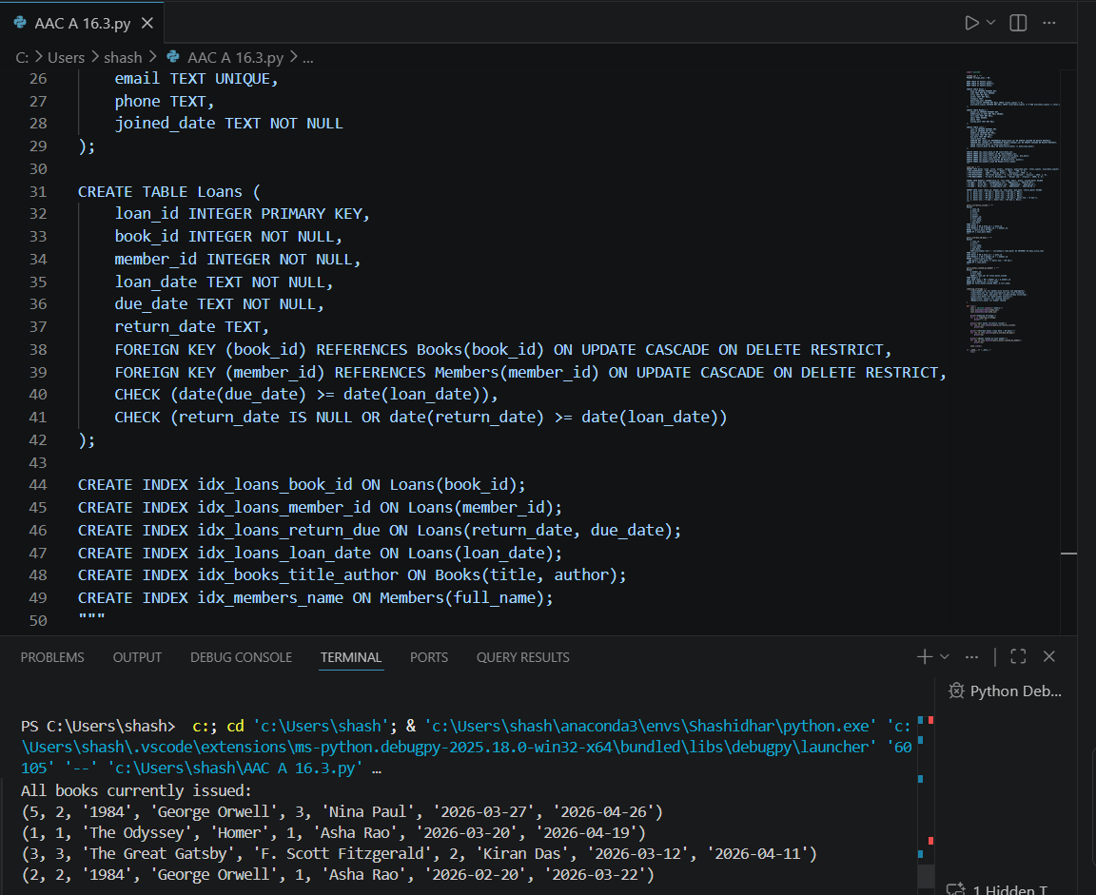  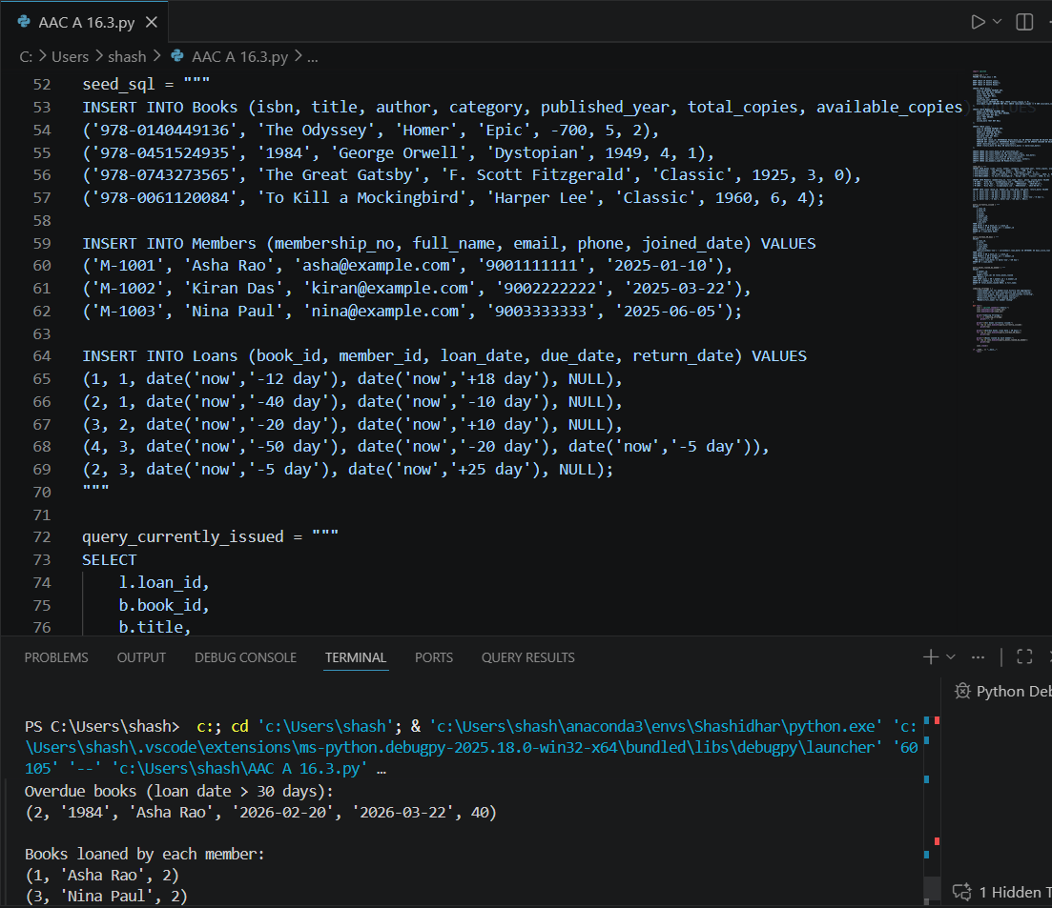  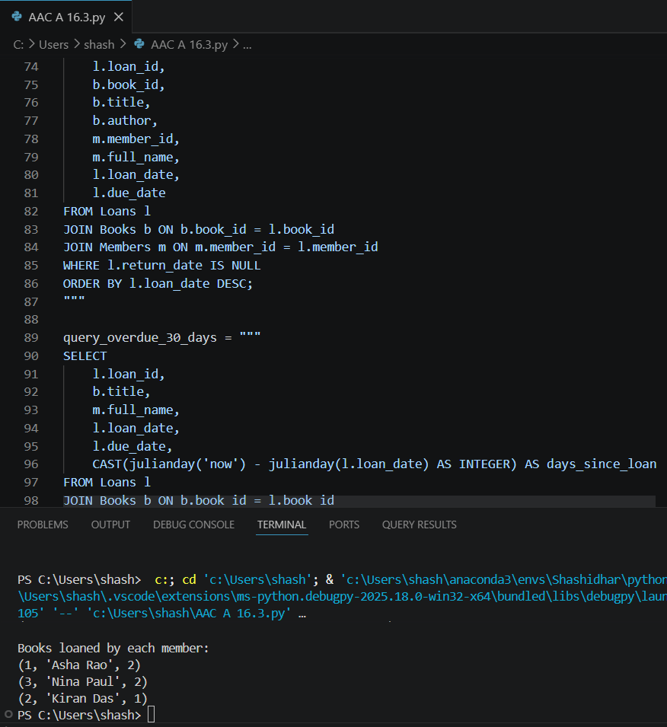  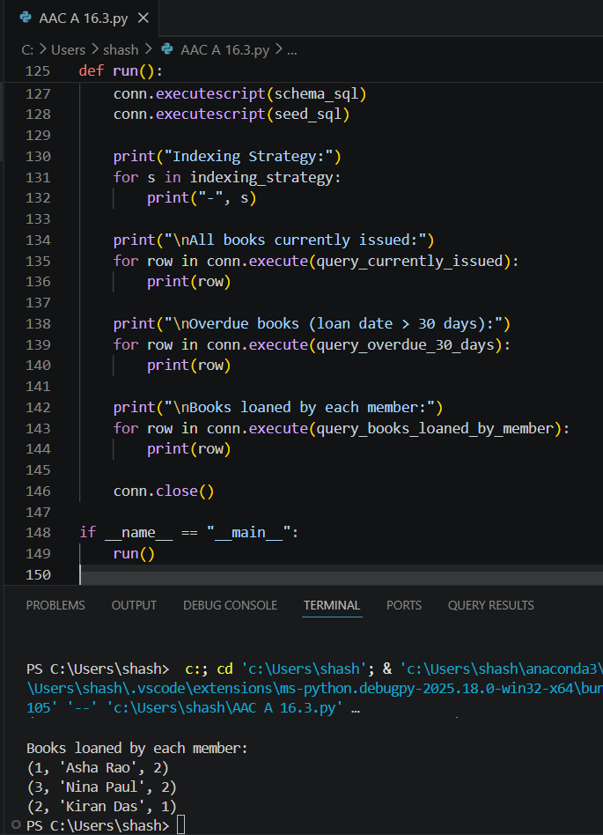  Task 4: Optimize Queries  Instructions:  - Use AI tools to analyze query efficiency.  - Optimize inefficient queries using joins, indexes, or reducing subqueries.  - Test optimized queries for correctness.  Starter Code Example:  -- Original query  SELECT * FROM Books WHERE author_id IN (SELECT author_id FROM Authors WHERE country='UK');  -- Optimized query  SELECT b.*  FROM Books b  JOIN Authors a ON b.author_id = a.author_id  WHERE a.country = 'UK';  Expected Output:  - Both queries return the same result: all books written by UK authors.  - Optimized query performs faster for larger datasets.  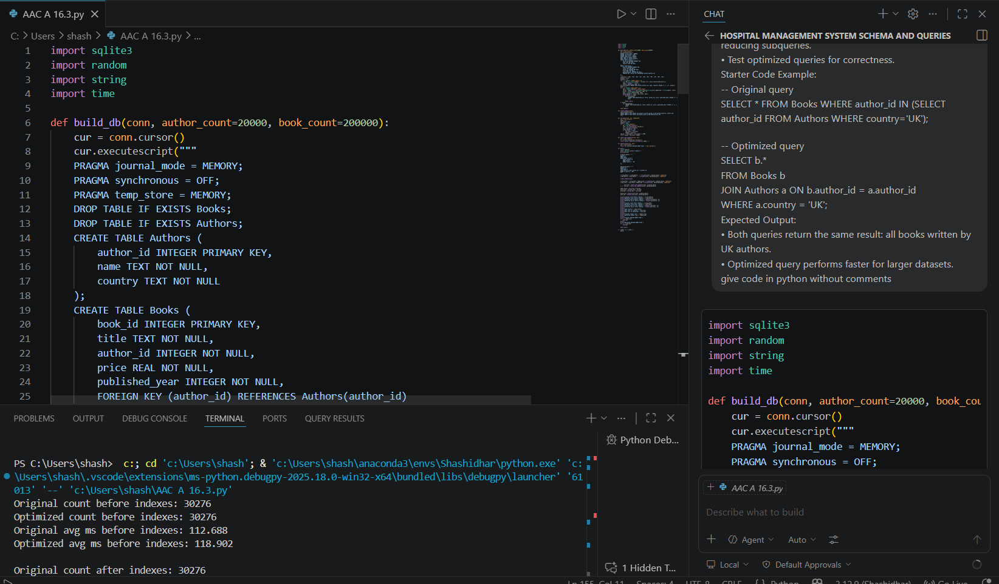  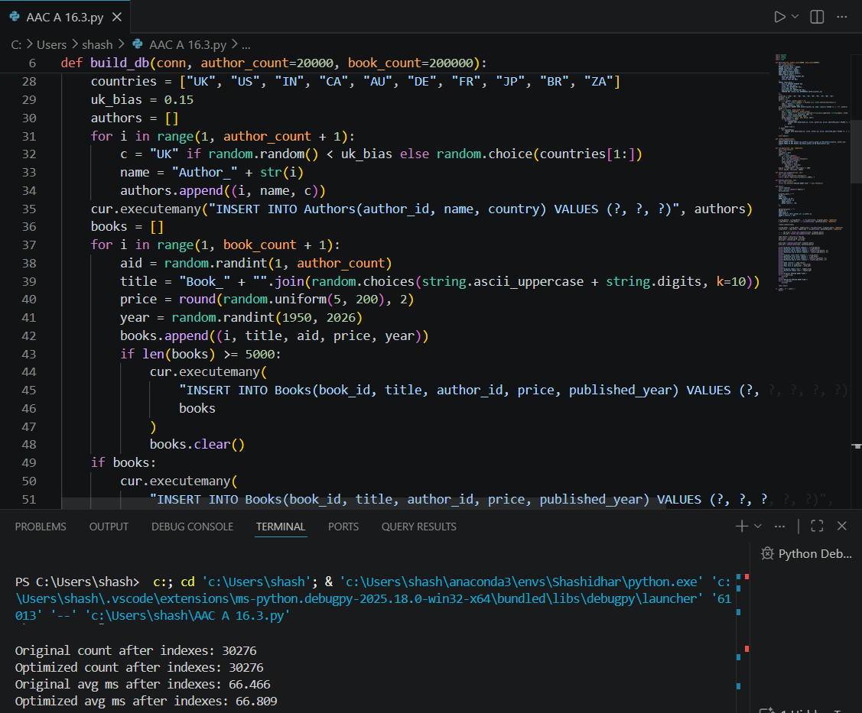  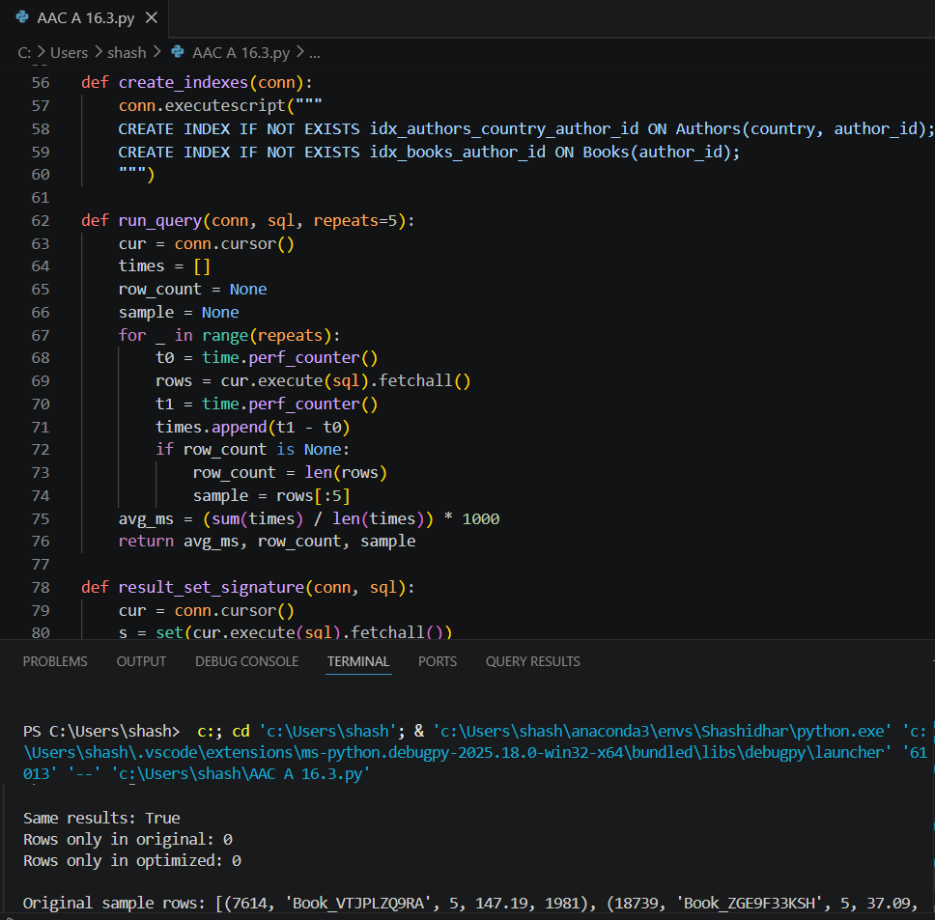  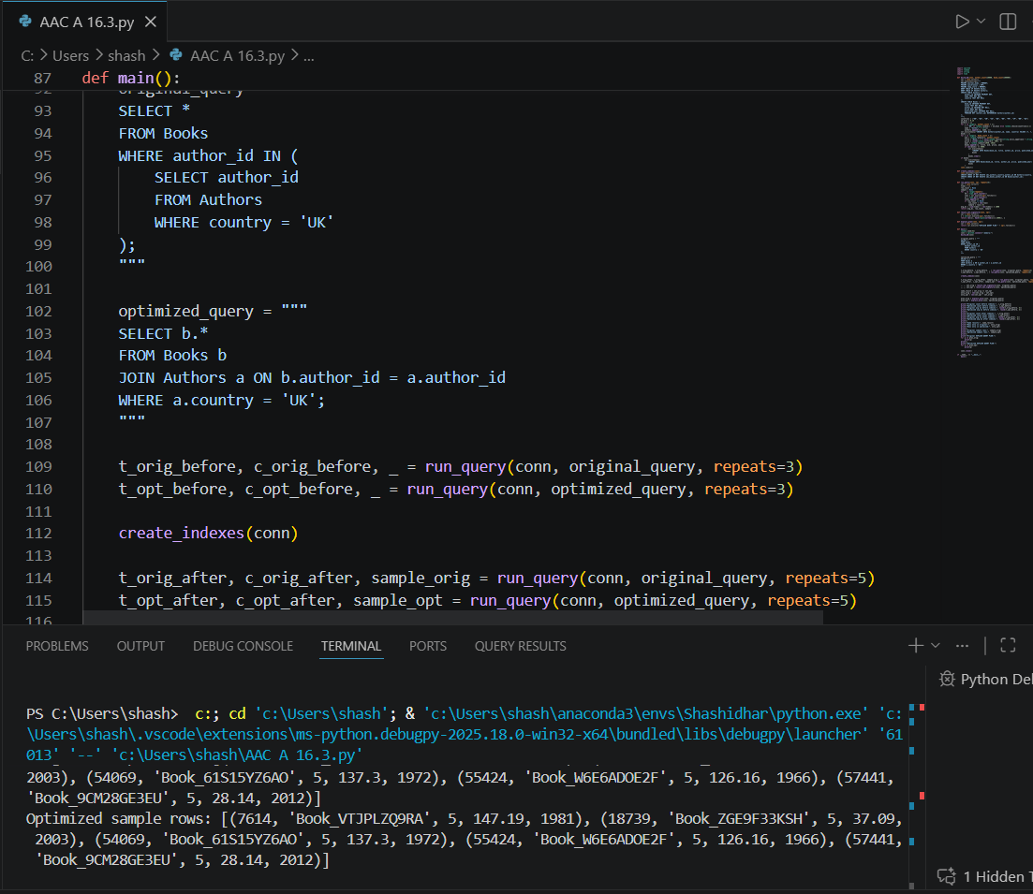  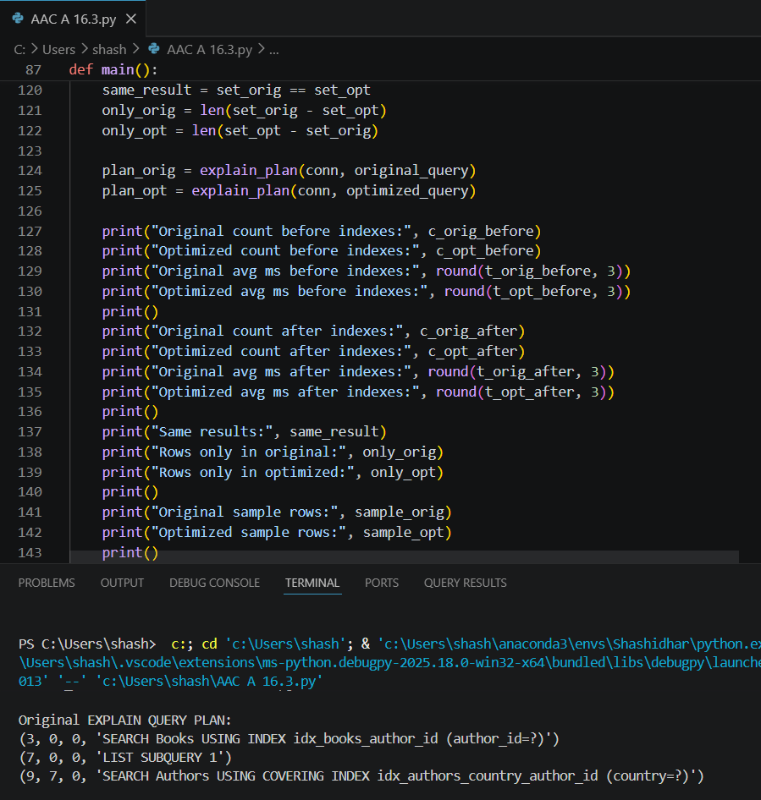  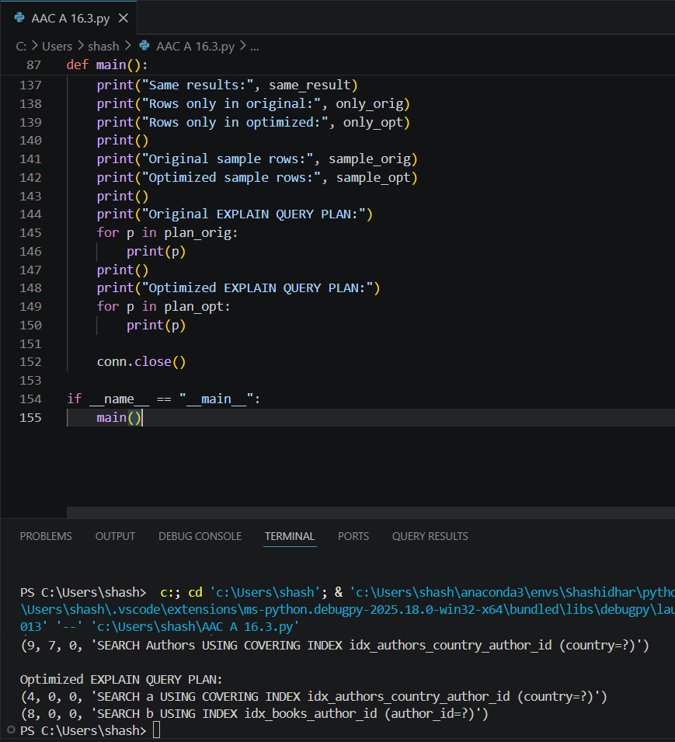  Task 5: University Course Registration  Scenario:  SR University needs a course registration system for students enrolling in different courses under faculty supervision.  - Use Copilot to design schema tables: Students, Courses, Faculty, and Registrations.  - Define relationships:  - Each student can register for multiple courses.  - Each course is taught by a faculty member.  - Write SQL queries to:  - List all students enrolled in a specific course.  - Find faculty members teaching more than 2 courses.  - Retrieve courses with the highest number of registrations.  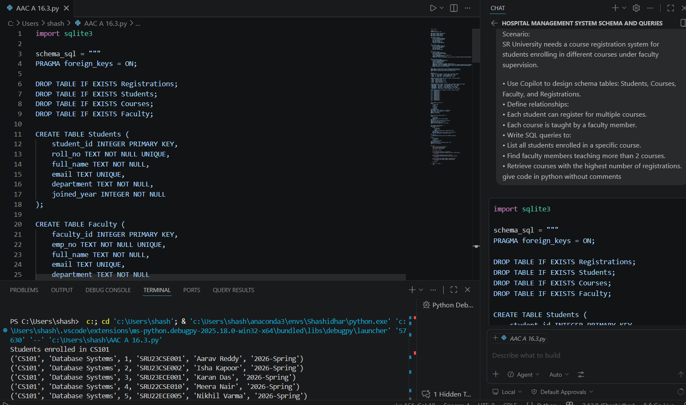  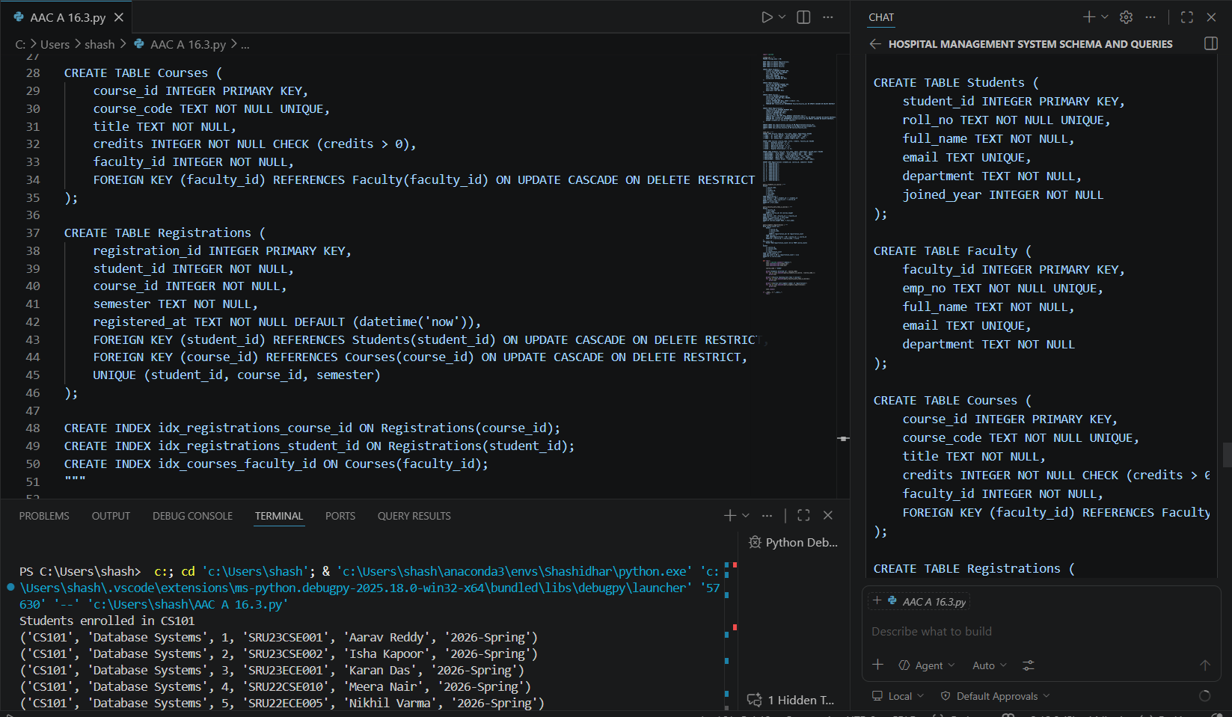  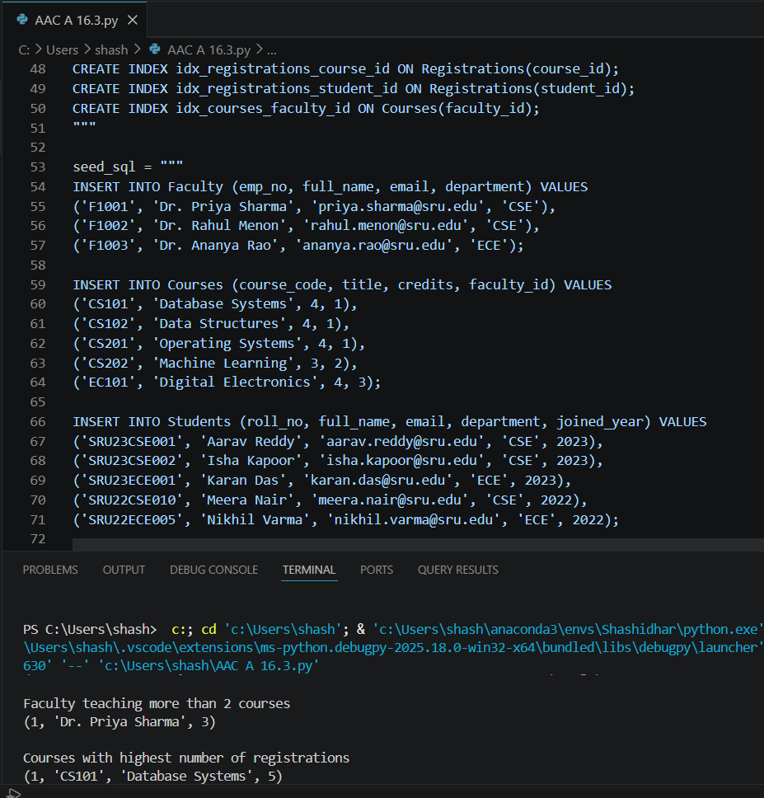  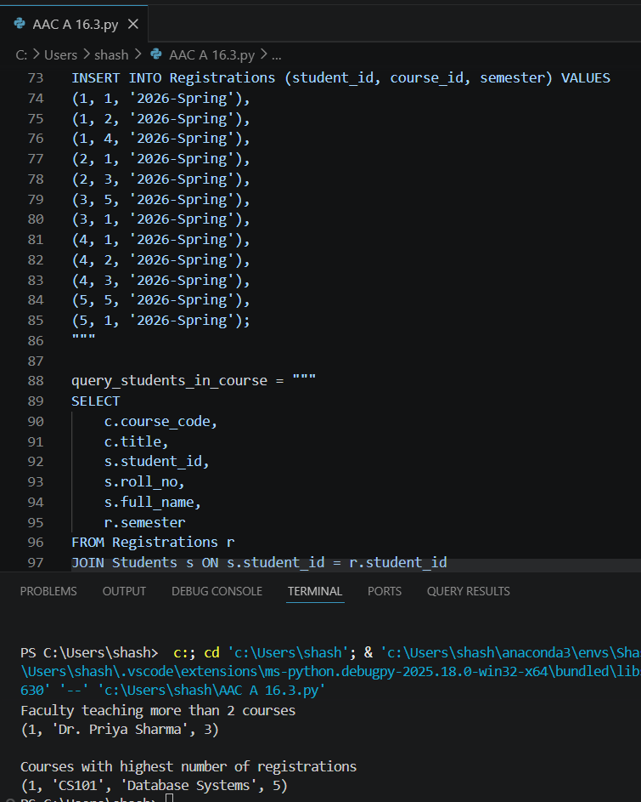  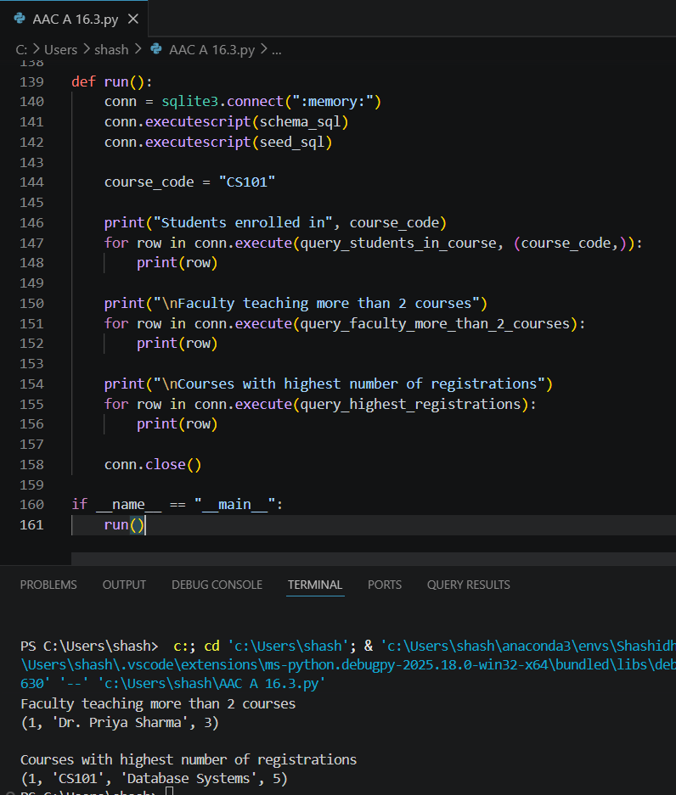  Note: Report should be submitted as a word document for all tasks in a single document with prompts, comments & code explanation, and output and if required, screenshots. |  |  |  |  |  | Week8 - Wednesday

